Stretching and Reed Exercises

Stretching: Things to Think About
- Stretching should not hurt, never push it to the point of discomfort
- Focus in on hands, wrists, arms, and shoulders
- Take big, relaxed breaths in and out with each stretch
- A consistent routine will put you in the right mind space for practice

Reed Exercises: Things to Think About
- ALWAYS CHECK IN WITH YOUR TUNER!
- Consistency is the aim, then accuracy. If you can’t get the exact pitch right away, aim for close and keep it there for each rep
- DO NOT use your hands to pull the reed in and out of your mouth
- DO NOT take away the support until you can confidently hold the reed steady with only your embouchure.
- Never stop the air during the exercises
- Breath all the way out and take a good breath in before starting/moving on to the next exercise.

Reed Exercises

Pitch: B-C is an acceptable range
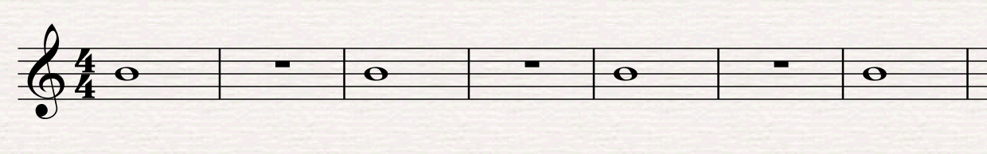

NOTE: If you struggle with playing sharp, aim for a B pitch, if you struggle playing flat, aim for a C pitch

Reed Push Up:
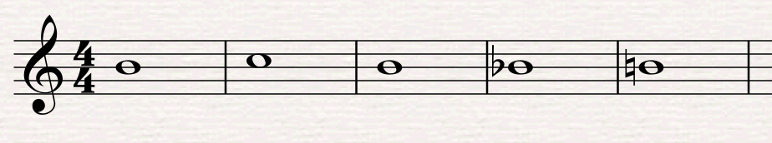

NOTE: Break this down and practice just one motion before putting the entire exercise together

Advanced Reed Push Up:
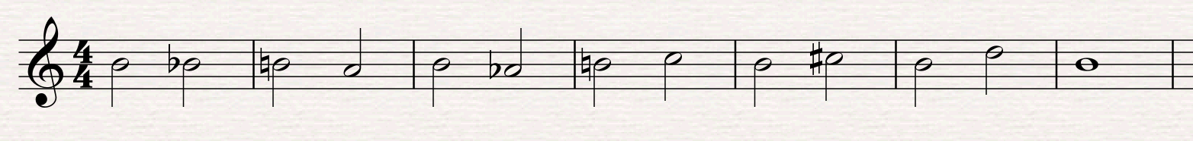

NOTE: As in the normal push up, break this down into smaller chunks until you feel confident

Alarm Exercise:
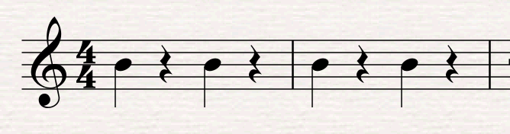

NOTE: Equal parts sound and silence.
Air should not stop.
Each note should sound exactly the same; start, middle, and end.
Try with tongue first and then air.

