Scales

Things to Remember:
- Start by playing all scales slurred. Focus on moving between notes without any extra sounds or breaks in the sound.
- Play slow enough that you use the correct fingerings and play all the correct notes the first time, then start to speed things up.
- Change up the order that you play the scales. Do not always follow the circle of 5ths or chromatic. Start with the hard, sharp scales sometimes.
- Challenge yourself by playing all scales to the highest and lowest note you know staying within the scale.
- Eventually all scales should be memorized.

Exercises
Play through all 12 major and/or all minor scales

OPTIONS:
- Play all major or minor scales, one octave, in one breath. This is easiest done by going up chromatically.
- Go up one scale, play the top note, go up one half step, then play the next scale down, going up one half step at the bottom (ex. Up C, down Db, up D, etc.)
- Change the rhythms of the scales. Play them as straight 16th notes, play them in a triplet rhythm, etc.
Major Scales
Minor Scales – Take as many of these 2 octaves as possible
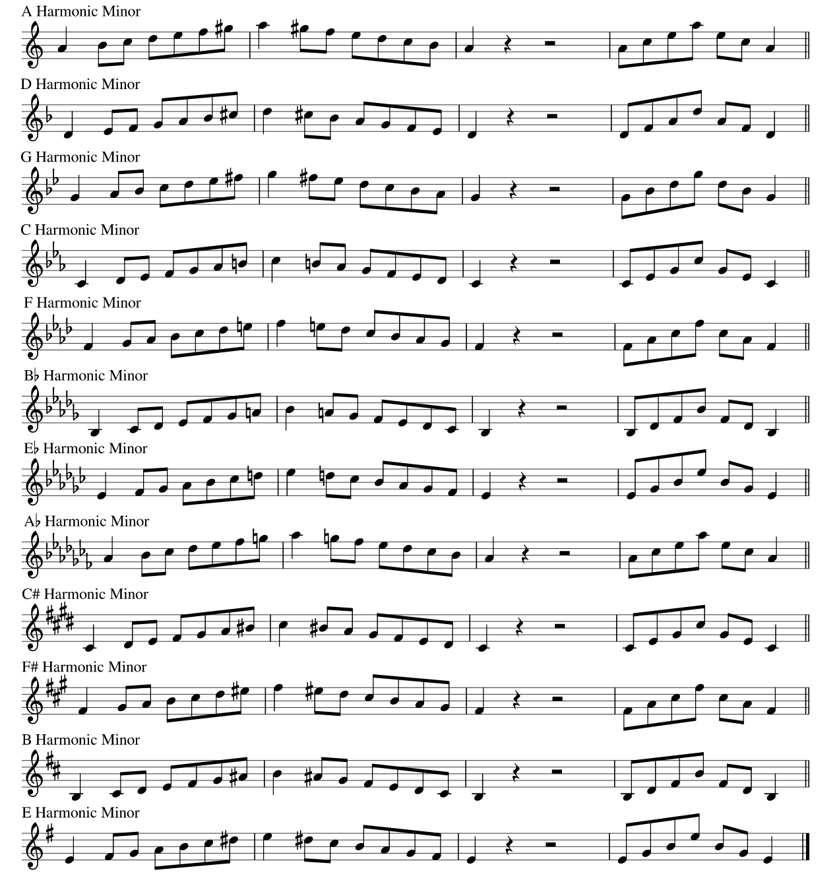

Scales in 3rds – Follow this pattern for all major/minor scales
