Long Tones

Things to Remember
- ALWAYS PLAY WITH YOUR TUNER!
- Though a metronome is not necessary for this specific set of exercises, a slow tempo should be chosen.
- Focus on the air and sound between the notes. There should be no finger flubs, cracks, or breaks in the sound
- Put into practice some of the reed exercises you just worked through, especially in the remington and the octave slurs.
- This is the time to practice the extremes of your dynamic range. Push yourself softer than you think you can go. Play louder than you technically have control over. While we never want to do that in music, this is the time to push the edges of your dynamic levels.

Exercises

Low Note Chromatic:
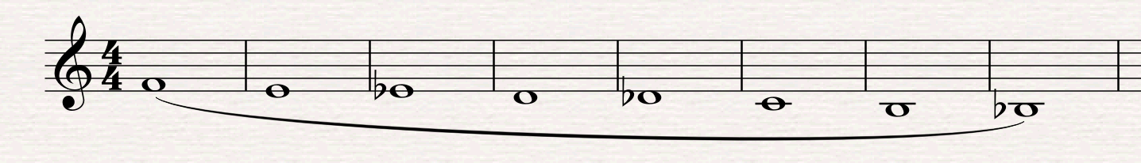

NOTE: Start by playing this at a comfortable dynamic, then challenge yourself to start and keep it soft as you go into the lower range of the oboe.

Remington:
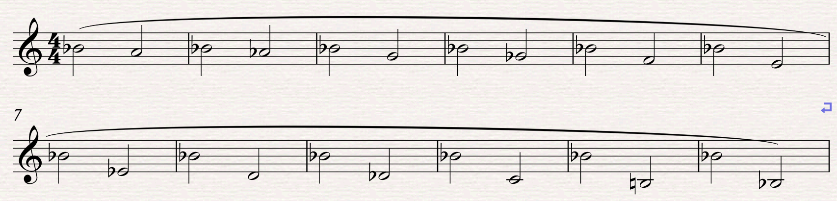

NOTE: Breath when you need to, but always restart the note that you are on. Don’t use a breath as an excuse to cheat a difficult interval.

Be willing to break down and work on the single interval that gives you the most trouble.

The goal is to get all the intervals to speak just as easily as the first one. This one might take repetition.

Octave Slurs: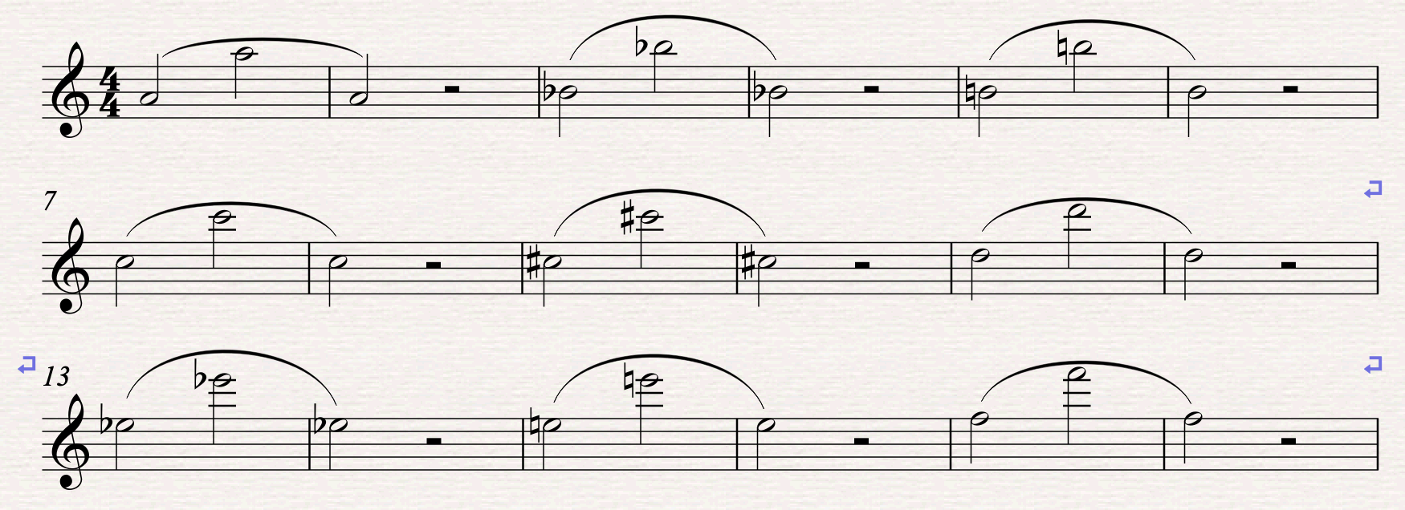

NOTE: A TUNER IS NECESSARY FOR THIS EXERCISE! The whole point is to try and tune the 2nd and 3rd octaves of the oboe.

To challenge yourself, add the octave below when possible.

Dynamics:
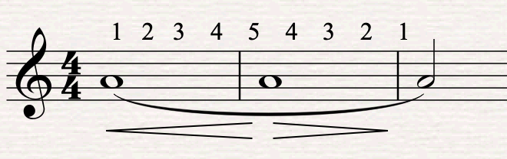

NOTE: Do not always use the same note. Change it up from day to day depending on what the music needs.

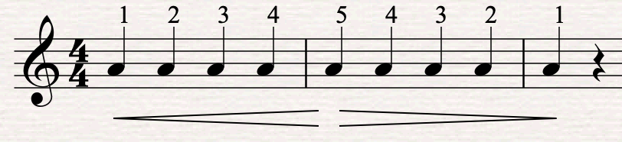

NOTE: Be sure no two quarter notes sound exactly the same.

