Articulation

Things to Remember:
- ALWAYS PLAY THESE EXERCISES WITH THE METRONOME1!!!
- Rhythmic consistency is of utmost importance. It doesn’t matter how fast you can tongue two notes if you can’t keep it up for a consistent passage.
- NEVER stop your air when working on fast articulation. The beginning and end of the note should be with your tongue. (ONLY when working on speed, not for legato/slower music)
- Change up the note that you work your speed at. You will find that some notes articulate much easier than others.

Exercises:

Speed Exercise:
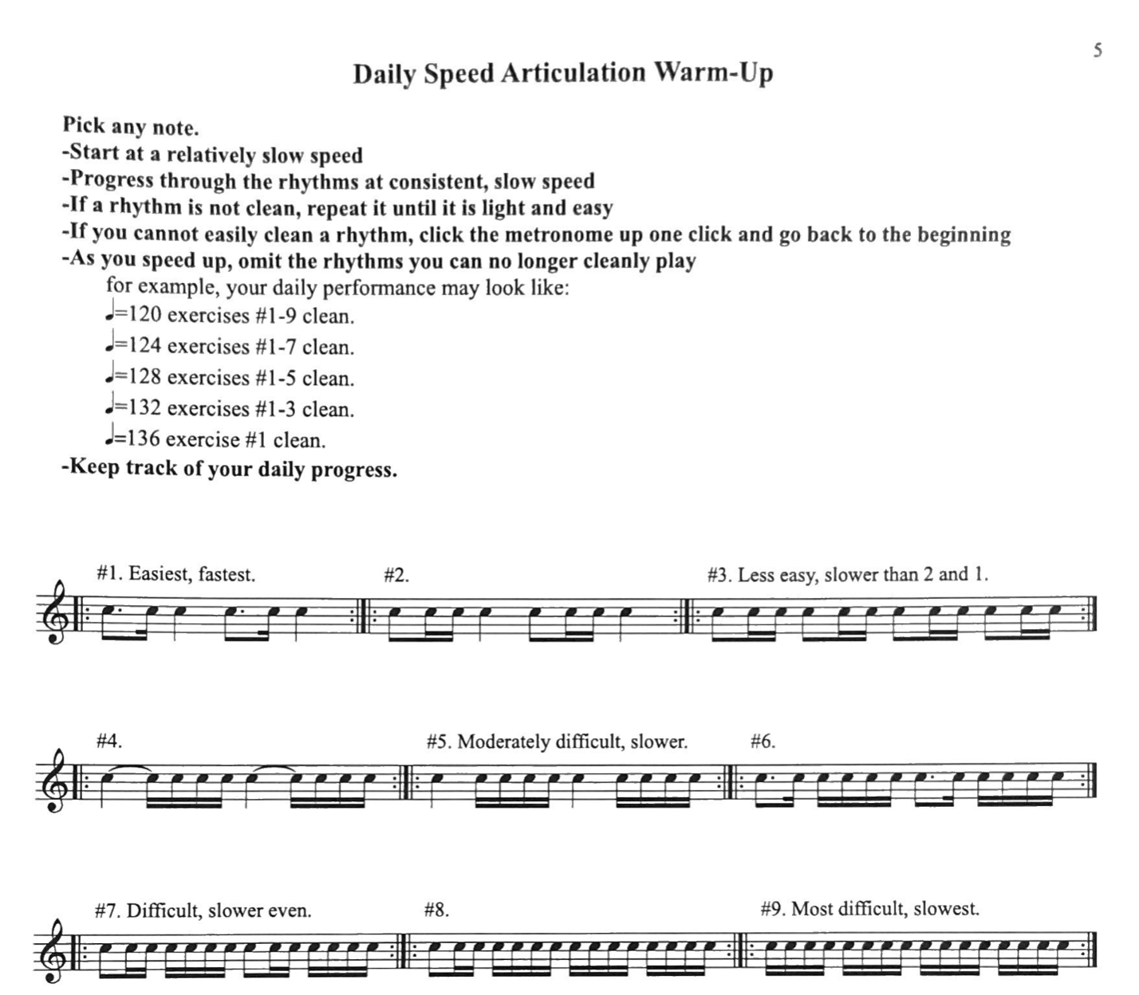

Scale Exercises:

Go back to your scales and change up the articulation. Try and tongue all your scales at a quick pace without your fingers and tongue getting off. Practice your scales in the different speed rhythms, changing notes on each measure or changing notes with each articulation.

Barret Articulation Studies:
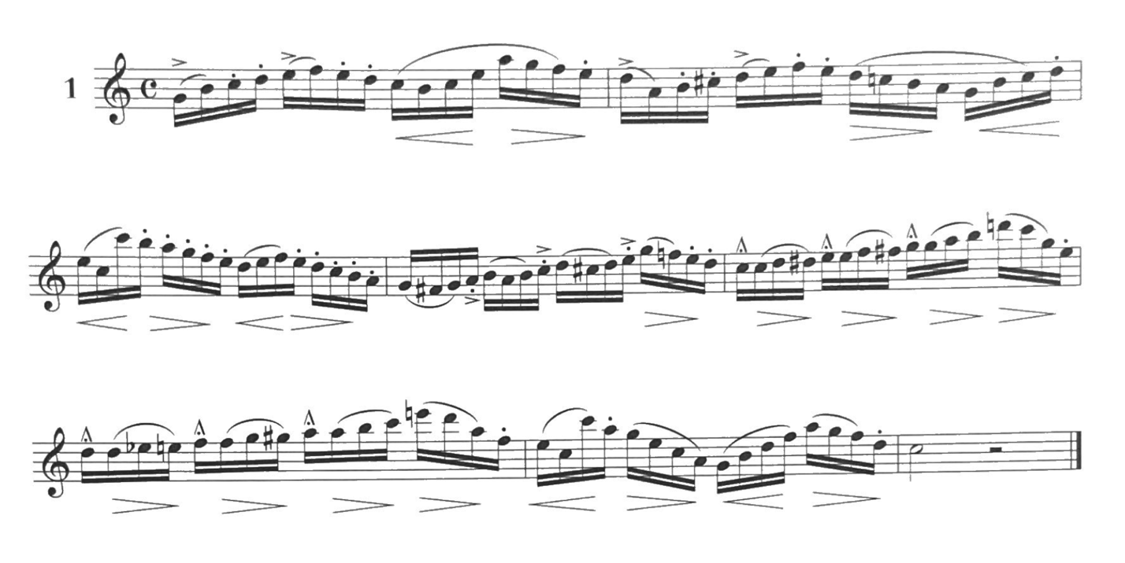

You can find the other 11 studies at:

https://imslp.simssa.ca/files/imglnks/usimg/2/2f/IMSLP95231-PMLP196018-Barret_-_Complete_Method_for_the_Oboe_(2nd_ed).pdf

The articulation studies start on page 76.

REMEMBER: Play these SLOWLY at first, paying attention to all the different articulation markings and making sure there is a difference between each. Once you are comfortable at the slow tempo, WITH all the different articulations, you can speed it up.

